# Logo



Color Schema

Color Palette URL: <https://coolors.co/e8f4f8-3a6b9c-9f7d58-b0c9dd>

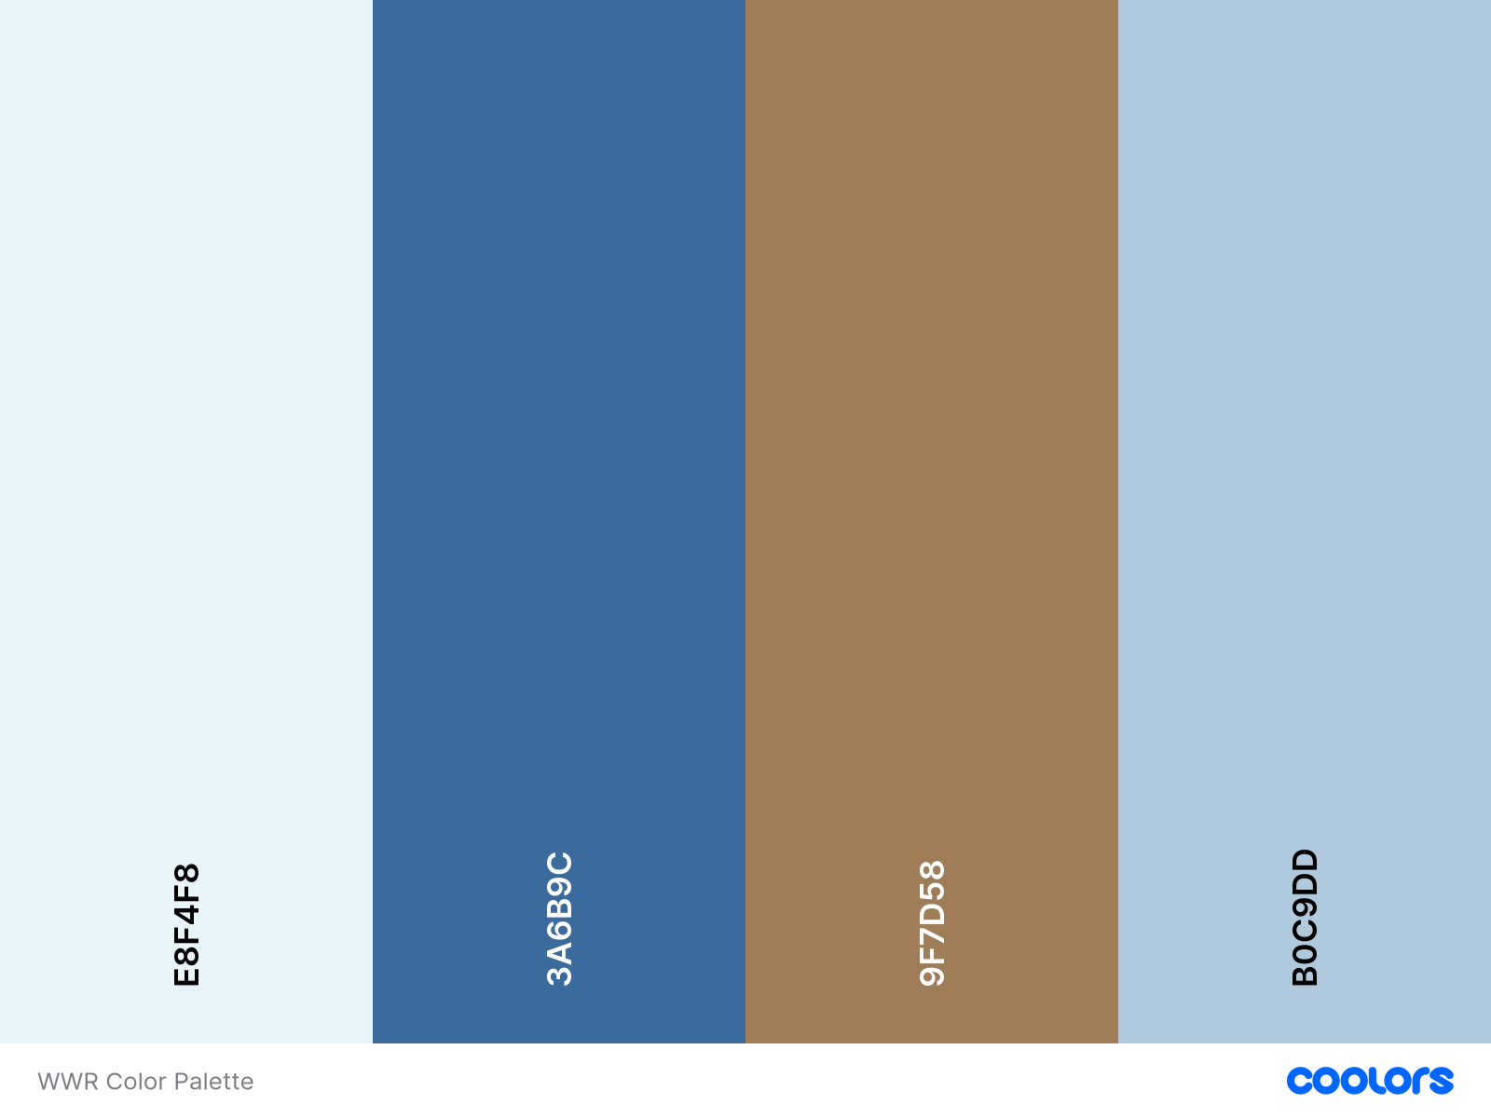

Typography

Headings: Roboto 100, 400

Body: Poppins 300, 400, 500